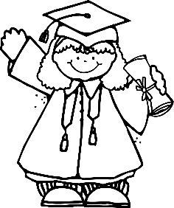

**Mrs. Courtney’s News**

cscoggins@tipton-county.com

**May 7-11, 2018**

Upcoming Info and Reminders

Show and Tell Day:

Your child may bring a small show and tell item on the following day. (Items should be able to fit in your child’s backpack)

Wednesday, May 9- Girls

Thursday, May 10- Boys

For our End of the Year Party on May 17, please bring a beach towel, chalk, bubbles, and a sack lunch. We will pass out our 4th nine weeks awards at 11:00 in our classroom. Please arrive at 10:45 if you would like to attend the awards ceremony.

* **Our lunch is at 10:35**. Please arrive promptly if you are bringing food with you for your child that day.
* **May 7th –** **11th:** Teacher Appreciation Week
* **May 11th:** Mother/Son Glow in the Dark Dance Party 6-8PM (presale tickets only)
* **May 11th:** Library Books are due
* **May 16th:** Kindergarten Field Day (Parents are welcome to attend ☺, please wear tennis shoes and class shirt )
* **May 17th:** Kindergarten End of the Year Party and Awards Day
* **May 17th:** Domino’s Pizza Night
* **May 22:** Graduation at 9:45 (a sign out sheet will be in the classroom)
* **May 23rd:** Half Day of School (Car riders dismissed at 10:40 and 1st load buses at 10:45)/Report Cards go home

As of May 7th, we will not allow any charging on cafeteria accounts. Also, **no** checks after May 11th.

Our Weekly Skills

We will be completing Common Assessments and 4th nine weeks testing.

**Kindergarten Graduation is May 22nd!**

8:15am (Ms. Jackie, Ms. Jessica, Mrs. Kelly)

**9:45am** (Mrs. Annalyn, **Mrs. Courtney**, Mrs. Lauren, Mrs. Madison)

**Graduation Dress:** Please wear your Sunday best. No hair bows or jeans. Students will be wearing a graduation cap.

**A sign out sheet will be in the room. I look forward to seeing you all on our special day. ☺**

